# L-25H

**CNC HORIZONTAL LATHE**

**TECHNICAL AGREEMENT**

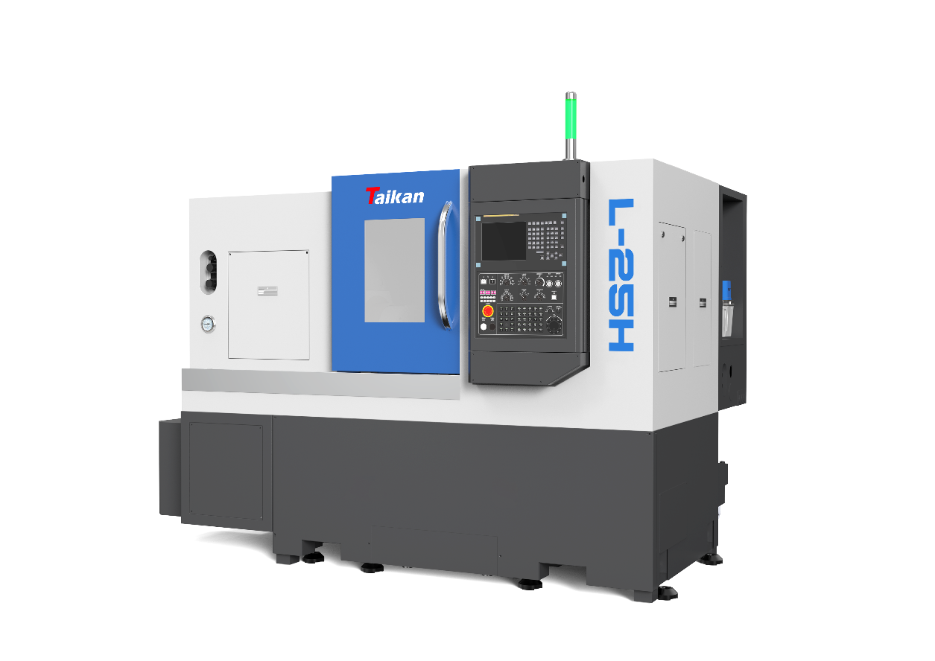 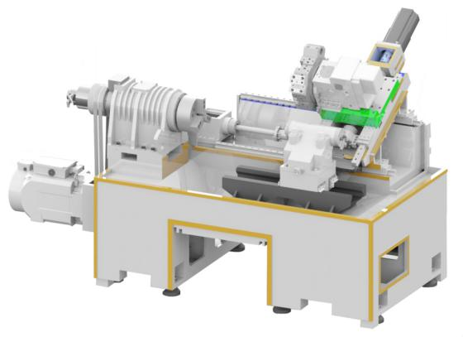

1. **Technical description of equipment**

L-25H CNC Horizontal Turning Machine is a two-coordinate two-axis linkage, semi-closed-loop CNC machine tool. This machine tool has an integrated layout of machine, electricity and liquid. It adopts a fully enclosed protective cover, the sliding door opens to the left, and the rotating console is located on the fixed protective cover at the right end, which is easy to operate. Each servo feed axis adopts a high-speed silent ball screw, which is directly connected by an elastic coupling, which has fast moving speed, low noise, high positioning accuracy and repeated positioning accuracy; the servo motor is equipped with an absolute encoder, which has no accumulated error, no memory, no need for memory, There is no need to find a reference point, and the location information will not be lost after the power is turned off. This machine tool has strong function, high precision, reasonable layout, beautiful appearance, easy operation and convenient maintenance.

* Overall: The machine tool is a mechanical, electrical and hydraulic integrated layout, with a 30° overall inclined bed, with compact structure, high rigidity,It has the advantages of smooth chip removal and convenient operation; the guide rail is a rolling guide rail, and the driving part adopts a high-speed silent ball screw, which has the advantages of high speed, less heat, and high positioning accuracy; the machine tool is fully enclosed protection, automatic chip removal, automatic lubrication , Automatic cooling. The basic large parts are made of high-quality resin sand molding and high-strength cast iron material, so that the machine tool can obtain high rigidity and stable precision.
* Spindle: The main drive system of this machine tool is driven by a high-performance servo motor, which drives the spindle to rotate through a belt. The spindle speed range is 0-4000r/min. The front support of the spindle adopts double row cylindrical roller bearing and double high-precision angular contact ball bearing, and the rear support adopts double row cylindrical roller bearing to meet the bearing requirements of axial and radial cutting forces.
* Tool turret: This machine tool adopts servo turret, which has fast tool changing speed and high reliability.
* Tailstock: Hydraulic tailstock, live center structure, high precision, high rigidity and reliable performance.
* Drive: The vertical and horizontal drive adopts FANUC high-performance servo motor, which has high positioning accuracy and flexible and reliable action.
* System: Equipped with high-performance FANUC 0i-TF PLUS (3B) CNC system, optional βi series high-performance AC spindle motor and servo motor, which ensures the stability of machine tool control, as well as the CNC machining functions and auxiliary functions required by users.

The quality of the processed and assembled finished products of all machine tool parts complies with the product drawings and related technical requirements, and complies with the relevant provisions of GB/T17421-2000 "General Inspection of Machine Tools" and GB/T16462-1996 "Accuracy Inspection of CNC Horizontal Lathes".

1. **Parameter and configuration**

|  |  |  |  |  |
| --- | --- | --- | --- | --- |
| Items | | Unit | Parameter | Remarks |
| Processing range | Max. rotation diameter | mm | Φ500 |  |
| Max. processing diameter (axis/plate) | mm | Φ200/Φ250 |  |
| Max. processing length | mm | 450 | 800 (optional large motor) |
| Max. bar diameter | mm | Φ45 |  |
| Travel | X –axis travel | mm | 190 |  |
| X –axis motor power/stall torque | kW/Nm | 1.8/11 |  |
| Z –axis travel | mm | 500 | 830 (optional large motor) |
| Z –axis motor power/stall torque | kW/Nm | 1.8/11 |  |
| Spindle | Output power(S1/S6) | kW | 7.5/11 |  |
| Spindle end form |  | A2-5 |  |
| Spindle rotary speed | r/min | 0-6000 |  |
| Hole diameter | mm | Φ57 |  |
| Chuck | Hydraulic 3-jaw chuck | inch | 6 | Hollow |
| Tailstock | Tailstock sleeve diameter/travel | mm | Φ70/100 | Optional |
| Tailstock sleeve taper hole | Morse | Morse 4# | Live center |
| Guideway  & ballscrew | X-axis guide rail specification | mm | 35 |  |
| Z-axis guide rail specification | mm | 35 |  |
| X-axis screw specification | mm | Φ32/10 |  |
| Z-axis screw specification | mm | Φ32/10 |  |
| Speed | X-axis rapid traverse speed | m/min | 30 |  |
| Z-axis rapid traverse speed | m/min | 30 |  |
| Cutting Feed Rate | mm/min | 1~8000 |  |
| Tool holder | Tool capacity | T | 12 |  |
| Tool indexing time | sec/bit | 0.5 |  |
| Turning tool holder specification | mm | 25×25 |  |
| Max. boring tool diameter | mm | Φ40 |  |
| Accuracy | X axis positioning accuracy | mm | 0.006 |  |
| Z axis positioning accuracy | mm | 0.008 |  |
| X axis repeatabilitys | mm | 0.004 |  |
| Z axis repeatability | mm | 0.004 |  |
| Others | Power Supply Capacity | kVA | 22 |  |
| Coolant volume | L | 150 |  |
| Dimension | mm | 2500*1700*1680 | Manual Chip Removal Tank |
| Total weight | kg | 3400 |  |

***#:* No further notice will be given for the change of machine tool dimensions due to configuration.**

**Tal**

1. **Standard configuration**

|  |  |  |  |
| --- | --- | --- | --- |
| No. | Name | Quantity | Remarks |
| 1 | FANUC 0i—TF PLUS（3B） | 1 |  |
| 2 | Main Motor 7.5/11kW | 1 | Domestic |
| 3 | Manual chip removal & coolant tank components | 1 | Manual Rear Chip Removal |
| 4 | 12-station servo turret | 1 |  |
| 5 | 6-inch 3-jaw hollow hydraulic chuck | 1 | Hollow Cylinder, Hollow Tie Rod |
| 6 | Cooling system | 1 |  |
| 7 | Automatic lubrication system | 1 |  |
| 8 | Hydraulic system | 1 |  |
| 9 | Three-color light | 1 |  |
| 10 | Lighting system | 1 |  |
| 11 | Attachment | 1 | According to packing list |
| 12 | Machine standard technology document | 1 |  |
| 13 | Basic installation kit | 1 |  |

1. **Optional configuration. (Additional charge required)**

|  |  |  |  |
| --- | --- | --- | --- |
| No. | Optional item | Whether | Remarks |
| 1 | Hydraulic Tailstock |  | Morse 4# |
| 2 | Motorized Spindle A2-5 |  | 14.5/17.8 kW |
| 3 | FANUC Main Motor 7.5/11 kW |  | FANUC full set |
| 4 | Automatic Side Chip Removal + Chip Cart (Right Side) |  | Machine dimensions (L×W×H): (approx.) 3900×1778×2027 mm |
| 5 | Automatic Rear Chip Removal + Chip Cart (Rear Side) |  | Machine dimensions (L×W×H): (approx.) 2498×3018×2027 mm |
| 6 | 6-inch Solid Chuck / Solid Hydraulic Cylinder |  |  |
| 7 | 8-inch Hollow Chuck / Hollow Hydraulic Cylinder |  |  |
| 8 | 8-inch Solid Chuck / Solid Hydraulic Cylinder |  |  |
| 9 | Coolant Gun |  |  |
| 10 | Tool Setter |  | Specifications depend on chuck size |
| 11 | Servo Feed Unit |  | 1 meter |
| 12 | Oil Bath Feed Unit |  |  |
| 13 | Workpiece Catching Device |  |  |
| 14 | Oil-Water Separator |  |  |
| 15 | Grating Scale |  |  |
| 16 | Mechanical Oil Mist Collector |  |  |
| 17 | Safety Door Lock |  |  |
| 18 | Hydraulic Cylinder Travel Detection Switch |  |  |
| 19 | Reducing Sleeve |  | Ф32 |
| 20 | Reducing Sleeve |  | Ф25 |
| 21 | Reducing Sleeve |  | Ф20 |
| Note: If this configuration is selected, mark √ in the corresponding item. | | | |

1. **Turret standard tool holder, boring tool set configuration**

|  |  |  |  |
| --- | --- | --- | --- |
| NAME & SPECIFICATION | | QUANTITY | REMARK |
| Tool holder | 25×25 end turning tool holder | 1 |  |
| Ф40 boring tool holder | 4 |  |
| External circular tool pressing block | 12 |  |
| End face tool press block | 1 |  |

1. **Mechanical delivery list**

|  |  |  |  |
| --- | --- | --- | --- |
| No. | Items | Quantity | Remarks |
| 1 | User’s guide | 1 | (scan the QR code to download) |
| 2 | Compliance certification | 1 |  |
| 3 | Packing list | 1 |  |
| 4 | Foundation plans | 1 | Provide within 1 month after signing the contract |
| 5 | Lathe operating instructions | 1 |  |

1. **Brands of main parts of equipment**

|  |  |  |  |
| --- | --- | --- | --- |
| No. | Description | Brand | Remark |
| 1 | CNC system | FAUNC 0i—TF PLUS（3B） |  |
| 2 | Domestic Main motor | Mistech /CTB |  |
| 3 | Spindle | RIYE |  |
| 4 | Spindle bearing | NSK/SKF/NTN/FAG | Japan/Germany |
| 5 | Ball screw | Taiwan PMI | C3 level or equivalent quality universal interchange |
| 6 | Roller Linear Guides | Taiwan PMI | P grade or equivalent quality universal |
| 7 | Hydraulic chuck | Domestic/Jiahe |  |
| 8 | Cylinder | Domestic |  | |
| 9 | Turret | Taiwanese investment/Zhijie |  | |
| 10 | Joined Wide Angle Belt | Gates |  | |
| 11 | Lubrication system | Taiwan |  | |
| 12 | Tri-color light | Domestic |  | |
| 13 | Main electrical components | Schneider/LS |  | |
| 14 | Hydraulic station | Domestic | (Taiwanese-invested pump) | |
| 15 | Water pump | Domestic |  | |
| Note: When supply is insufficient, other brands of products will be used instead, but the quality will not be lower than the listed configurations. | | | | |

1. **FANUC System Main Function List (Some functions require host machine configuration to be enabled)**

| **No.** | **Function** | **Description** | **Remarks** |
| --- | --- | --- | --- |
| 1 | Number of control axes | 10 axes | Maximum total number of controlled axes + dedicated PMC controlled axes |
| 2 | Simultaneous control of the number of axes | 7 axes | 5 feed axes, 2 spindles |
| 3 | axis name | XYZ、UVW、ABC any |  |
| 4 | Minimum input unit | 0.001mm |  |
| 5 | Dual position feedback |  | Optional |
| 6 | High Response Vector Control | HRV control |  |
| 7 | Imperial/Metric Conversion |  |  |
| 8 | Machine interlock |  |  |
| 9 | emergency stop |  |  |
| 10 | Overtravel Alarm |  |  |
| 11 | Stored stroke check |  |  |
| 12 | mirror |  |  |
| 13 | location tracking |  |  |
| 14 | Abnormal load detection |  |  |
| 15 | automatic running |  |  |
| 16 | MDI operation |  |  |
| 17 | DNC operation |  |  |
| 18 | Program number search |  |  |
| 19 | Sequence number search |  |  |
| 20 | program restart |  |  |
| 21 | dry run |  |  |
| 22 | single block |  |  |
| 23 | JOG (jog) feed |  |  |
| 24 | Manual reference point return |  |  |
| 25 | handwheel feed | 1 个 |  |
| 26 | Handwheel feed rate | ×1，×10，×100 |  |
| 27 | Nano imputation |  |  |
| 28 | position | G00 |  |
| 29 | Accurate stop method | G61 |  |
| 30 | Tapping method | G63 |  |
| 31 | Cutting method | G64 |  |
| 32 | accurate stop | G09 |  |
| 33 | Linear interpolation | G01 |  |
| 34 | Circular interpolation | G02、G03 |  |
| 35 | pause | G04 |  |
| 36 | Thread cutting, synchronized feed |  |  |
| 37 | Multi-start thread cutting |  |  |
| 38 | Continuous thread cutting |  |  |
| 39 | Variable pitch thread cutting |  |  |
| 40 | Polygon processing |  |  |
| 41 | Polygon machining between spindles |  |  |
| 42 | skip function | G31 |  |
| 43 | return to reference point | G28 |  |
| 44 | Back to reference point check | G27 |  |
| 45 | Return to the second reference point | G30 |  |
| 46 | Rapid traverse override | F0、25、50、100% |  |
| 47 | feed per minute |  |  |
| 48 | feed per revolution |  |  |
| 49 | Automatic acceleration/deceleration |  |  |
| 50 | Feedrate override |  |  |
| 51 | JOG feed override |  |  |
| 52 | tape code | Automatic recognition of EIA/ISO |  |
| 53 | logo skip |  |  |
| 54 | parity check | Horizontal and vertical parity check |  |
| 55 | Control input/output |  |  |
| 56 | Select block skip |  |  |
| 57 | maximum command value | ±9 digits |  |
| 58 | Program number search |  |  |
| 59 | Sequence number | N8 digits |  |
| 60 | Absolute/incremental instructions | Can be mixed in the same |  |
| 61 | decimal point programming |  |  |
| 62 | Diameter/Radius Designation |  |  |
| 63 | plane selection | G17、G18、G19 |  |
| 64 | Rotation axis specification |  |  |
| 65 | Coordinate system setting |  |  |
| 66 | Automatic coordinate system setting |  |  |
| 67 | Workpiece coordinate system | G52~G59 |  |
| 68 | Workpiece coordinate value preset |  |  |
| 69 | Direct input of workpiece origin offset |  |  |
| 70 | Direct input of drawing size |  |  |
| 71 | Chamfer/Corner R |  |  |
| 72 | Programmable data input | G10 |  |
| 73 | Programmable parameter input |  |  |
| 74 | subroutine call | 10 levels of nesting |  |
| 75 | User macro program |  |  |
| 76 | canned cycle |  |  |
| 77 | Arc radius R command |  |  |
| 78 | Coordinate system offset |  |  |
| 79 | Coordinate system offset direct input |  |  |
| 80 | Accessibility | M8 digits |  |
| 81 | Spindle function | S5 digits, binary output |  |
| 82 | Spindle serial output | S5 digits, serial output |  |
| 83 | Spindle analog output | S5 digits, analog output, only1 |  |
| 84 | Spindle override | 0~120% |  |
| 85 | Spindle positioning | 1 |  |
| 86 | Spindle synchronization control |  |  |
| 87 | Tool function |  |  |
| 88 | Number of tool compensations | 128 |  |
| 89 | Tool position offset |  |  |
| 90 | Tool diameter, tool nose radius compensation |  |  |
| 91 | Tool geometry/wear compensation |  |  |
| 92 | Direct input of tool offset measurements |  |  |
| 93 | Tool life management |  |  |
| 94 | Extended tool life management |  |  |
| 95 | Backlash compensation |  |  |
| 96 | Rapid traverse/feed backlash compensation |  |  |
| 97 | Number of login programs | 1000 |  |
| 98 | Workpiece program editing |  |  |
| 99 | program protection |  |  |
| 100 | Password function |  |  |
| 101 | extension editor |  |  |
| 102 | Background editing |  |  |
| 103 | Status Display |  |  |
| 104 | Clock function |  |  |
| 105 | Current location display |  |  |
| 106 | Program comment display | Program name 31 |  |
| 107 | Parameter setting display |  |  |
| 108 | Parameter checksum function |  |  |
| 109 | Alarm display |  |  |
| 110 | Alarm history display |  |  |
| 111 | Operation history display |  |  |
| 112 | Working time/number of parts display |  |  |
| 113 | actual speed display |  |  |
| 114 | Actual spindle rotation number/T code display |  |  |
| 115 | program directory display |  |  |
| 116 | Operation monitor screen |  |  |
| 117 | Servo adjustment screen |  |  |
| 118 | Spindle adjustment screen |  |  |
| 119 | Servo waveform display |  |  |
| 120 | Maintenance information screen |  |  |
| 121 | display language |  |  |
| 122 | data protection key |  |  |
| 123 | Help function |  |  |
| 124 | Self-diagnostic function |  |  |
| 125 | Hardware/Software System Configuration |  |  |
| 126 | External data input |  |  |
| 127 | external program input |  |  |
| 128 | External part number search |  |  |
| 129 | External program number search |  |  |
| 130 | Memory card input/output |  |  |
| 131 | Screen hard copy |  |  |
| 132 | Embedded Ethernet |  |  |
| 133 | Data automatic backup |  |  |
| 134 | PMC system |  |  |
| 135 | AC Servo Amplifier |  |  |
| 136 | AC Servo Spindle Amplifier |  |  |
| **Special Note: For more functions, please refer to the FAUNC 0i—TF PLUS series specification selection guide. Due to changes in machine tool configuration and differences in design, please refer to the agreement when ordering** | | | |

1. **General requirements for equipment and installation and commissioning**

1. General requirements for equipment

1.1. Equipment use environment: Maintaining a constant ambient temperature is an essential factor for precision machining.

1.2. Working conditions:

(1) Three-phase AC power supply: 380V±5%; 50Hz±1Hz, main power line 10mm² or larger, grounding line 10mm² or larger.

(2) Ambient temperature: The ambient temperature must be maintained at 17~25℃. If the precision requirements for processed parts are not high, it can be relaxed to 5~40℃. Storage or transportation temperature -20~60℃.

(3) Room temperature change: The ambient temperature change within 24 hours is within ±2℃;

(4) Relative humidity: within 75% (no condensation);

(5) Altitude: below 1000m;

(6) Vibration: below 0.2G;

(7) Foundation requirements: Bearing capacity above 50KN/m²;

(8) Keep away from light sources, vibration sources and heat sources, high-frequency generators, discharge motors, welding machines, etc., to avoid electrical interference that may cause the machine tool NC system to malfunction.

1.3. If the voltage in the area of use is unstable, the machine tool should be equipped with a voltage-stabilized power supply to ensure the normal operation of the machine tool.

1.4. The machine tool should have reliable grounding: the grounding wire is a copper wire with a wire diameter of no less than 10mm² and a grounding resistance of less than 4 ohms.

1.5. To ensure the normal operation of the equipment, if the compressed air does not meet the air source requirements, a set of air source purification devices (dehumidification, degreasing, filtration) should be added before the machine tool intake.